Year 1 and 2 (led by Samantha / Carmen):
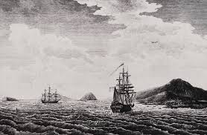
I came from the dream-time
From the dusty red-soil plains
I am the ancient heart
The keeper of the flame
I stood upon the rocky shores
I watched the tall ships come
For forty thousand years I've been
The first Australian

Year 3 (led by Ava / Allegra):
I came upon the prison ship
Bowed down by iron chains
I fought the land, endured the lash
And waited for the rains
I'm a settler, I'm a farmer's wife
On a dry and barren run
A convict, then a free man
I became Australian

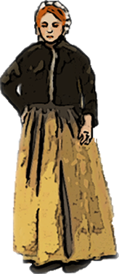
Year 4 (led by Madi / Emily):
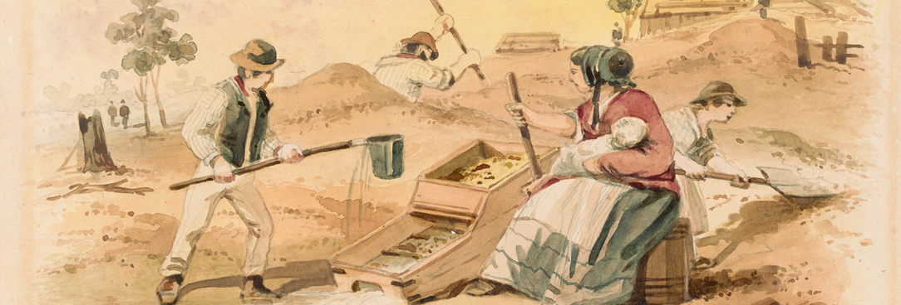
I'm the daughter of a digger
Who sought the mother lode
The girl became a woman
On the long and dusty road
I'm a child of the Depression
I saw the good times come
I'm a bushie, I'm a battler
I am Australian

We are one, but we are many
And from all the lands on earth we come
We'll share a dream and sing with one voice
"I am, you are, we are Australian"

Year 5 (led by Ruby / Aurora):
I'm a teller of stories
I'm a singer of songs
I am Albert Namatjira
And I paint the ghostly gums
I'm Clancy on his horse
I'm Ned Kelly on the run
I'm the one who waltzed Matilda
I am Australian

Year 6 (led by Charlotte / Trista):
I'm the hot wind from the desert
I'm the black soil of the plains
I'm the mountains and the valleys
I'm the drought and flooding rains
I am the rock, I am the sky
The rivers when they run
The spirit of this great land
I am Australian

We are one, but we are many
And from all the lands on earth we come
We'll share a dream and sing with one voice
"I am, you are, we are Australian"
We are one, but we are many
And from all the lands on earth we come
We'll share a dream and sing with one voice
"I am, you are, we are Australian"
"I am, you are, we are Australian"

